System Capacity & Care Load Analytics for Unaccompanied Children

Author: Shramanth P. Acharya Mentor: Saiprasad Kagne

Abstract
This study presents a data-driven analytical framework for monitoring system capacity within the Unaccompanied Alien Children (UAC) Program administered by the U.S. Department of Health and Human Services (HHS) [1]. Using daily operational data from 2023 to 2025, the analysis applies exploratory data techniques and derives key capacity metrics to evaluate system load, inflow–outflow balance, and backlog accumulation.
Key indicators such as Total System Load, Net Intake Pressure, Care Load Volatility, and Discharge Offset Ratio are developed to quantify operational stress. Additionally, an interactive Streamlit-based dashboard is implemented to enable real-time monitoring and decision support.
The findings demonstrate the importance of data-driven analytics in improving operational awareness and supporting proactive decision-making in large-scale humanitarian care systems.
Keywords:
Healthcare Capacity Analytics, Unaccompanied Children, System Load Monitoring, Time-Series Analysis, Decision Support Systems, Streamlit Dashboard

Introduction

The flow of migrants moving from one country to another is subject to change depending on various factors such as political conflicts, economic challenges, and crises. The migrants moving from one country to another often cause a sudden increase in the number of vulnerable child migrants entering a country. In the United States, the care and protection of vulnerable child migrants are handled by a program referred to as the Unaccompanied Alien Children Program (UAC), which is under the U.S. Department of Health and Human Services (HHS) [1]. The program is intended to provide temporary care, shelter, and necessary services to migrant children below 18 years who are found entering the U.S. without a parent or a legal guardian. According to federal guidelines, such migrant children are those who lack immigration status and are thus placed under protective custody awaiting a safe transfer to a verified sponsor.
Figure 1 Logo of U.S. Department of Health and Human Services (HHS)

The workflow of the UAC system is a multi-stage process that involves a humanitarian care pipeline. The system starts by apprehending child migrants at the border by U.S. Customs and Border Protection (CBP) officials. The child migrants are then transferred to a facility that is under the Office of Refugee Resettlement within HHS for housing while awaiting a sponsor to take care of them. The UAC system thus requires effective management of resources to ensure that vulnerable child migrants are provided with adequate care while awaiting a sponsor to take care of them.

However, managing this system is particularly difficult during times of high migration inflow. This is because sudden increases in border encounters can quickly overwhelm shelter systems and healthcare services. In such situations, emergency systems may be required to be initiated to accommodate these inflows of children. Thus, without adequate monitoring and forecasting systems in place, this system may quickly turn from being proactive to reactive.

Data-driven analytics is particularly important in helping to improve operational awareness and capacity management within such systems. By analyzing daily operational data on intakes, discharges, and facility occupancies, policymakers and administrators can better understand system dynamics and anticipate times of high inflow. Analytical frameworks are particularly important in helping to develop quantitative indicators that can be used to assess system stress, inflow-outflow balance, and backlog accumulation.

Literature Review
Migration research has increasingly emphasized the importance of structured care systems for vulnerable populations such as unaccompanied migrant children. Various studies have examined the healthcare, social support, and policy challenges associated with managing large numbers of unaccompanied minors within humanitarian reception systems. These studies provide important insights into system capacity management, healthcare accessibility, and the design of analytical frameworks for monitoring migration-related services.
One important area of research focuses on the structure and organization of reception systems for unaccompanied minors. A study by researchers from Ghent University developed an analytical framework to compare reception structures for unaccompanied refugee minors across different European countries. The research highlights that reception systems differ significantly across regions due to variations in policy frameworks, institutional arrangements, and care delivery mechanisms. The authors propose an analytical model based on four dimensions: separation versus integration, control versus autonomy, immigration control versus welfare protection, and low versus high care intensity. These dimensions help explain how institutional design choices influence the quality of care and well-being of unaccompanied minors. The framework demonstrates that the organization of reception systems plays a critical role in determining the continuity and effectiveness of care services for migrant children. [2]
Another important body of literature examines the healthcare and social challenges faced by unaccompanied children after arriving in host countries. Research conducted by the Migration Policy Institute highlights that many unaccompanied children experience significant physical and psychological stress due to the conditions in their countries of origin and the dangerous migration journey. These children may suffer from trauma, malnutrition, or untreated medical conditions, which require timely access to healthcare services. However, studies show that once children leave federal custody, they often encounter numerous barriers to healthcare access, including limited insurance coverage, language barriers, administrative complexity, and limited awareness of available services. These challenges can negatively affect both the short-term and long-term well-being of migrant children and may hinder their integration into communities. [3]
Further research has specifically examined the medical and mental health needs of unaccompanied children living in host communities. A joint report by the American Academy of Paediatrics and the Migration Policy Institute highlights that the number of unaccompanied children entering the United States has increased significantly in the past decade. Many of these children transition from federal custody to community settings while awaiting immigration proceedings. During this transition, access to healthcare services becomes particularly difficult. The report identifies several key barriers including gaps in health insurance coverage, insufficient coordination between federal agencies and local healthcare providers, and limited availability of culturally appropriate services. As a result, children may experience delays in receiving preventive care, vaccinations, and mental health support, which can have long-term implications for their health and development. [4]
These studies collectively highlight the complexity of managing humanitarian care systems for unaccompanied children. They demonstrate that effective support for migrant minors requires not only adequate shelter and social services but also coordinated healthcare systems and strong policy frameworks. However, much of the existing research focuses on policy analysis and social care structures, with limited emphasis on quantitative monitoring of system capacity and operational dynamics.
The present study contributes to this research gap by introducing a data-driven analytical framework for monitoring healthcare system capacity within the Unaccompanied Alien Children (UAC) program in the United States. By analysing operational time-series data and developing derived capacity metrics, the study aims to provide insights into system load, inflow–outflow balance, and backlog accumulation. Such analytical approaches can support evidence-based decision-making and improve the management of large-scale humanitarian care systems.

Dataset and Methodology

Dataset Description
The dataset used in the present research comprises daily operational statistics pertaining to the Unaccompanied Alien Children Program of the United States Department of Health and Human Services. It records the inflow of unaccompanied minors through the humanitarian care pipeline from apprehension by United States Customs and Border Protection through the humanitarian care process in HHS-operated care facilities and finally through discharge to verified sponsors. It covers a time range of 2023-2025.
The data set comprises a series of variables pertaining to a particular date in a day-to-day format. Among these variables, the column “Children apprehended and placed in CBP custody” indicates the total number of children encountered and placed in CBP custody on a particular day. It acts as a primary measure of inflows in the system on a daily basis. “Children in CBP custody” indicates the total number of children in CBP custody. It acts as a measure of the active population of children in the border processing phase of the care pipeline. “Children transferred out of CBP custody” indicates the total number of children transferred from CBP custody to HHS-operated care facilities. It acts as a measure of inflows in the humanitarian shelter phase of the pipeline.
For the HHS phase of the pipeline, “Children in HHS Care” indicates the total number of children in HHS-operated care facilities. It acts as a measure of the active population of children in the humanitarian shelter phase of the pipeline. Finally, “Children discharged from HHS Care” indicates the total number of children discharged from HHS care. It acts as a measure of the total population of children in the HHS phase of the pipeline.

Methodology
The analytical methodology adopted in this study follows a structured data analytics pipeline designed to transform raw operational data into meaningful capacity indicators. The process begins with data ingestion and structuring, where daily time-series records covering the period from 2023 to 2025 are loaded and standardized for analysis. The date variable is converted into a proper datetime format, ensuring chronological ordering of observations. To maintain consistency in the time-series analysis, a complete daily index is created so that any missing reporting dates can be detected and appropriately handled.
Following data ingestion, a data quality and validation stage is performed to ensure the reliability of the analysis. This step includes identifying missing or duplicated reporting dates and verifying logical constraints within the dataset. For example, the number of children transferred from CBP facilities cannot exceed the number currently held in CBP custody, and the number of children discharged from HHS care cannot exceed the number present within HHS facilities. Any anomalies detected during this process are flagged for transparency and documented to maintain the integrity of the analysis.
To better understand the operational dynamics of the care system, several derived healthcare capacity metrics were developed from the primary dataset variables. These metrics provide quantitative indicators of system utilization, inflow–outflow balance, and potential operational stress. By transforming raw operational counts into analytical measures, the study enables a clearer interpretation of how capacity within the Unaccompanied Alien Children Program evolves over time.

Total System Load
The Total System Load metric represents the combined number of children currently under the care of both border processing facilities and humanitarian shelters. It provides an overall measure of the number of individuals being supported by the system at any given time. This metric is computed by summing the number of children in custody at U.S. Customs and Border Protection facilities and those housed in shelters managed by the U.S. Department of Health and Human Services.
Formula:
$$\text{Total System Load}=\text{CBP Custody}+\text{HHS Care}$$
Tracking total system load over time allows analysts to observe overall capacity utilization and identify periods when the system is operating under increased demand.

Net Daily Intake
The Net Daily Intake metric measures the daily balance between the number of children entering the HHS care system and the number leaving it. It captures the difference between transfers from CBP custody into HHS facilities and the number of children discharged from HHS care after successful sponsor placement.
Formula:
$$\text{Net Daily Intake}=\text{Transfers to HHS}-\text{Discharges from HHS}$$
A positive value indicates that more children are entering the HHS system than leaving it, which can lead to an increase in system load. Conversely, a negative value suggests that discharges are exceeding incoming transfers, leading to a reduction in system occupancy.

Care Load Growth Rate
The Care Load Growth Rate measures the day-to-day percentage change in the total system load. This metric helps identify sudden increases or decreases in the number of children being supported by the care system and is particularly useful for detecting emerging pressure periods.
Formula:
$$\text{Growth Rate}=\frac{\text{Today’s Load}-\text{Yesterday’s Load}}{\text{Yesterday’s Load}}$$
By monitoring this rate over time, analysts can detect rapid growth phases in system demand and evaluate how quickly operational pressure is increasing.

Backlog Indicator
The Backlog Indicator is used to detect the accumulation of children within the care system when inflow consistently exceeds outflow. A backlog condition occurs when the net daily intake remains positive for several consecutive days, indicating that children are entering the system faster than they are being discharged.
In operational terms, a sustained positive net intake suggests that shelter capacity and processing resources may become increasingly strained if the trend continues. Identifying backlog periods allows administrators and policymakers to anticipate potential capacity shortages and implement mitigation strategies such as increasing shelter capacity, accelerating discharge processes, or reallocating resources.

KPI Analysis
To evaluate the operational efficiency and capacity utilization of the care system, a set of Key Performance Indicators (KPIs) were developed from the underlying operational data. These indicators summarize complex system dynamics into interpretable metrics that allow administrators and policymakers to assess system performance. Within the context of the Unaccompanied Alien Children Program, KPIs help measure humanitarian care load, inflow–outflow balance, and the stability of the care pipeline managed by the U.S. Department of Health and Human Services.

Total Children Under Care
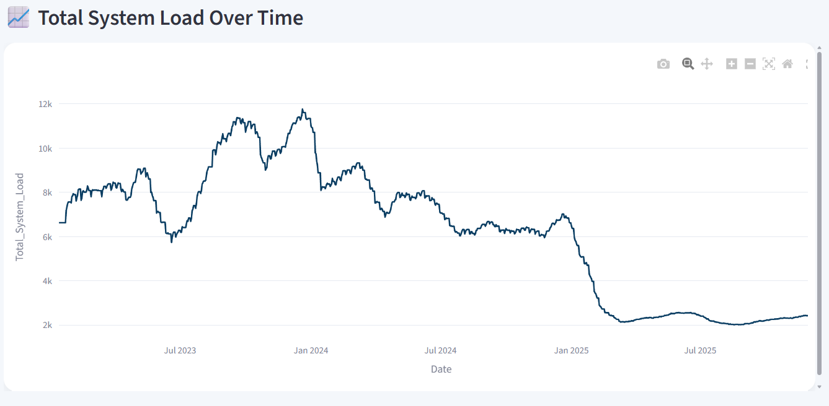
Figure 2 Trend of Total Children Under Care and Net Intake Pressure across the observation period.
The Total Children Under Care metric represents the total number of children currently supported within the entire care system. It is calculated by combining the number of children held in custody by U.S. Customs and Border Protection and those placed in shelters under HHS supervision. This KPI provides a system-wide indicator of humanitarian responsibility, reflecting the overall capacity burden faced by the program. Monitoring this value over time allows analysts to observe trends in total care demand and identify periods of elevated operational pressure.

Net Intake Pressure
The Net Intake Pressure indicator measures the imbalance between children entering and exiting the HHS care system. It is computed as the difference between transfers from CBP custody into HHS facilities and the number of children discharged from HHS care. When this value remains positive for an extended period, it indicates that more children are entering the system than leaving it, leading to increasing system load. This metric is therefore useful for detecting early signs of capacity strain within the care infrastructure.

Care Load Volatility Index
The Care Load Volatility Index measures the stability or variability of the system’s care load over time. It captures fluctuations in the total number of children under care and provides insight into whether the system is experiencing stable demand or sudden spikes in intake. High volatility suggests unpredictable inflow patterns, which may require flexible resource allocation and rapid operational adjustments to maintain service quality.

Backlog Accumulation Rate
The Backlog Accumulation Rate reflects the rate at which children accumulate within the system when inflow consistently exceeds outflow. Sustained backlog conditions can lead to increased occupancy levels within shelters and may require the expansion of available resources. Monitoring this KPI helps administrators identify extended pressure periods during which the system may approach or exceed its operational capacity.

Discharge Offset Ratio
The Discharge Offset Ratio measures the ability of the system to relieve care load by successfully discharging children from HHS facilities. It is calculated as the ratio of discharges to transfers into the system.
$$\text{Discharge Offset Ratio}=\frac{\text{Discharges}}{\text{Transfers}}$$
Higher values indicate that the system is effectively releasing children through sponsor placements, thereby maintaining balance between intake and discharge processes. Conversely, lower values suggest that discharges are lagging behind transfers, potentially leading to increased system pressure.

Streamlit Dashboard Implementation
To support interactive analysis and real-time monitoring of system capacity, a web-based analytics dashboard was developed using Streamlit. The dashboard serves as a decision-support tool designed to help policymakers, administrators, and analysts monitor operational trends within the UAC care pipeline. By integrating derived metrics, time-series visualizations, and interactive controls, the dashboard enables users to explore system dynamics and detect emerging capacity issues.
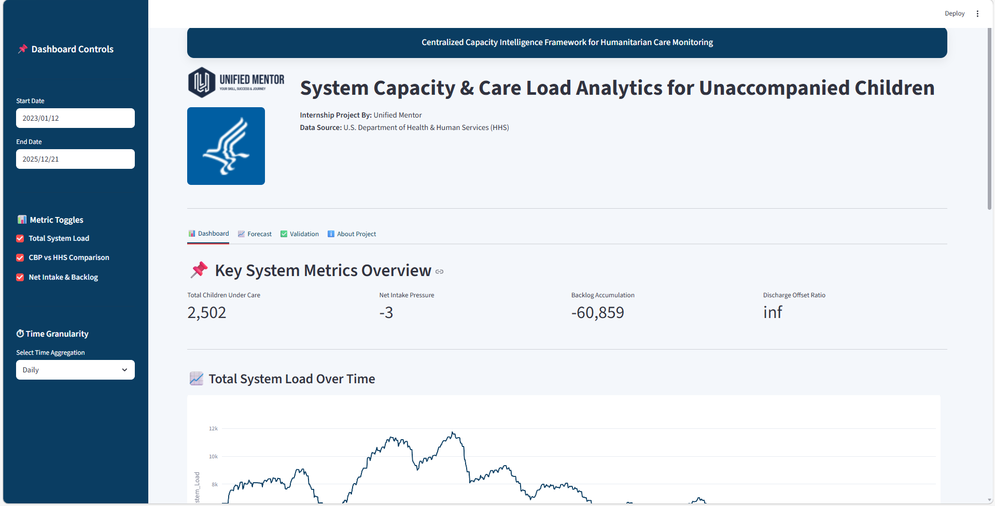
Figure 3 Streamlit Dashboard
The application consists of several core modules that provide different perspectives on system performance. The System Load Overview module presents a high-level visualization of total care load across the system, allowing users to observe long-term trends and changes in overall capacity utilization. The CBP vs HHS Load Comparison module compares the distribution of children across border custody facilities and HHS shelters, highlighting the relative burden carried by each stage of the care pipeline. The Net Intake and Backlog Trends module focuses on the balance between inflow and outflow, enabling users to identify periods where system demand exceeds discharge capacity. Finally, KPI Summary Cards provide a concise overview of key metrics, allowing users to quickly assess the current operational status of the system.
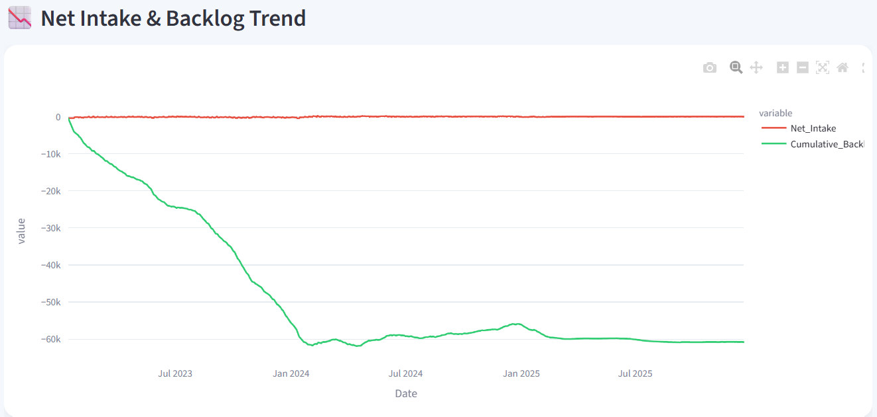
Figure 4 Net intake v/s Backlog Trend
In addition to these analytical modules, the dashboard provides several interactive user features that enhance data exploration. Users can filter data using a date range selector, allowing them to focus on specific time periods of interest. Metric selection toggles enable users to switch between different analytical indicators, while time granularity filters allow the visualization of trends at daily, weekly, or monthly intervals. These interactive elements make the dashboard a flexible tool for exploring system behaviour under varying conditions.
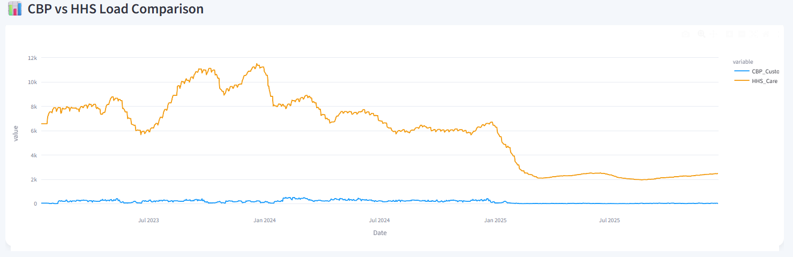
Figure 5 CBP v/s Load comparison
Overall, the dashboard demonstrates how modern data visualization platforms can support real-time monitoring and evidence-based decision-making in large-scale humanitarian care systems.
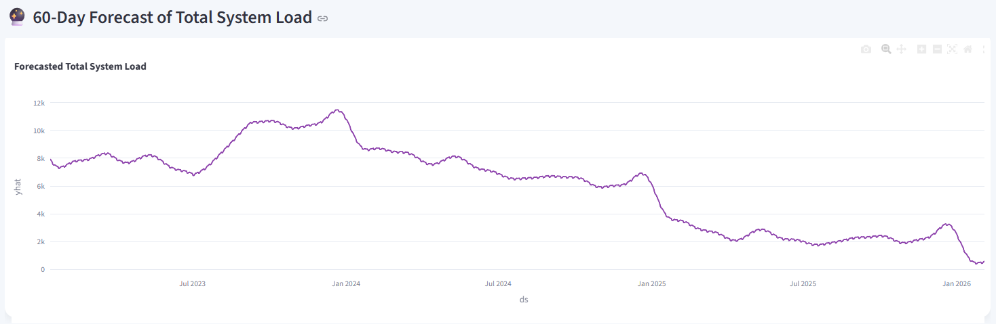
Figure 6 60 Day forecast 0f Total System load

Results and Key Insights
The analysis of daily operational data from 2023 to 2025 reveals several important insights regarding the dynamics of the UAC care system. Through the combination of exploratory data analysis and KPI-based monitoring, the study identifies patterns in system inflow, care load distribution, and capacity utilization.
First, the analysis indicates that certain periods exhibit significant spikes in daily intake, suggesting that migration flows into the system are not uniform over time. These spikes create temporary surges in system demand and require rapid adjustments in shelter capacity and operational resources.
Second, the results show that HHS-managed shelters absorb the majority of the system’s long-term care load once children are transferred from border custody. While CBP facilities serve as the initial intake point, the duration of stay within HHS shelters is generally longer, making them the primary component of sustained system capacity.
Third, the derived metrics reveal periods of positive net intake pressure, during which the number of incoming transfers exceeds the number of discharges. These periods contribute to the accumulation of backlog within the system and highlight the importance of maintaining efficient sponsor placement processes to ensure balanced system flow.
Finally, the KPI analysis demonstrates that monitoring indicators such as the Discharge Offset Ratio and Care Load Volatility Index provides valuable insights into the operational health of the system. By tracking these metrics, administrators can identify early warning signs of capacity strain and implement timely interventions to maintain stable care operations.

Conclusion
This analysis presents a data-driven analytical framework for monitoring the operational capacity of the Unaccompanied Alien Children Program administered by the U.S. Department of Health and Human Services [1]. The project focuses on transforming daily operational records into meaningful analytical indicators that provide visibility into the dynamics of the humanitarian care system. By systematically analysing intake, custody levels, transfers, and discharge patterns, the study highlights how data analytics can support more effective management of complex public service systems.
A key contribution of this work is the development of derived healthcare capacity metrics and Key Performance Indicators (KPIs) that capture system load, inflow–outflow balance, and operational stability. Metrics such as Total System Load, Net Intake Pressure, Care Load Volatility, Backlog Accumulation Rate, and Discharge Offset Ratio provide quantitative insights into how the system responds to fluctuations in migration inflows. These indicators enable analysts and policymakers to detect emerging pressure periods and evaluate the efficiency of resource utilization across different stages of the care pipeline.
The analytical framework is further supported by an interactive monitoring platform built using Streamlit, which integrates time-series analysis, KPI tracking, and interactive data exploration tools. The dashboard allows users to visualize care load distribution between border custody facilities and HHS-managed shelters, examine historical trends, and identify sustained periods of operational pressure. Such tools demonstrate the potential of modern data visualization technologies to enhance situational awareness and support evidence-based decision-making in humanitarian operations.
Overall, this project delivers a robust, policy-aligned healthcare analytics framework for monitoring the UAC care system. By translating raw operational data into structured capacity insights, the study empowers policymakers, administrators, and analysts to better understand system dynamics, evaluate operational performance, and improve the delivery of federally mandated child care services. The findings highlight the critical role of data-driven analytics and real-time monitoring systems in strengthening the resilience and effectiveness of large-scale humanitarian care programs.

References

[1] | “U.S. Department of Health and Human Services (HHS),” US Government, [Online]. Available: https://www.hhs.gov/.
[2] | M. B. O. U. S. A. M. R. F. V. &. I. D. Ine Lietaert, “The development of an analytical framework to compare reception structures for unaccompanied,” European Journal of Social Work, p. 18, 2019.
[3] | K. G. S. H. K. M. E. W. Mark Greenberg, “Strengthening Services for Unaccompanied Children in U.S. Communities,” p. 53, June 2021.
[4] | J. B. a. K. Fredricks, “A Path to Meeting the Medical and Mental Health Needs of Unaccompanied Children in U.S. Communities,” p. 42, April 2023.

